TDR Document

# Introduction

In this report, I will be describing the major implementations of the techniques employed for development of a VR experience.

I’ve decided to make an escape room game for the VR experience. The objectives of the game are to search each room by interacting with buttons and objects to find pieces of code to memorise. There will be a timer of 2 minutes to find all the balls or else you hit game over and restart.

# Controller-based interaction

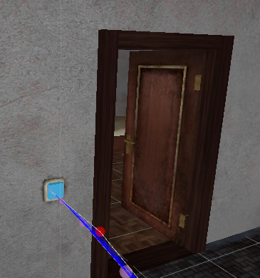For the controller based interaction, I have switches for doors when we hover over with our ray interactors, it opens the door, using the door script for the event. 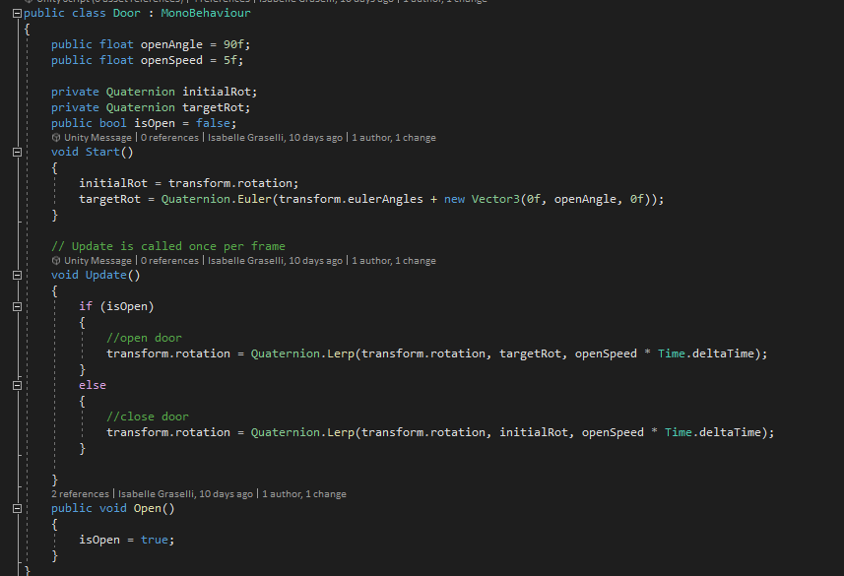

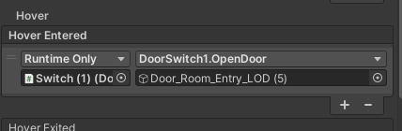

For the pickable balls in the environment, I made a script using the XRGrabInteractable class and added functions for events when selected and on release. Added the score manage instance of adding the points and set the game object set active to false after we release the ball.

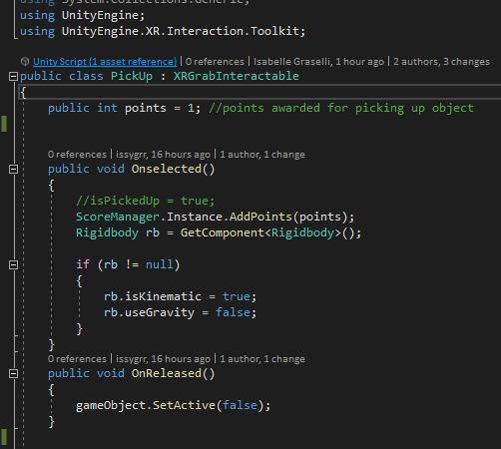

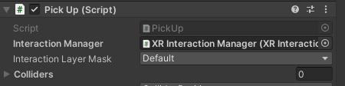

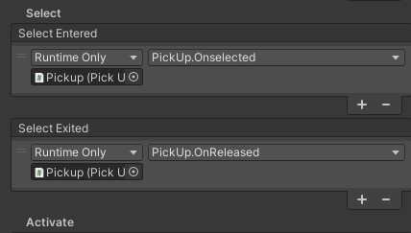

# UI Interaction

For UI interactions, I have 4 sets of UI, I have a start one with two buttons for starting the timer and quit button. When you press start, it sets the current UI active to false and the Timer UI is shown. On the inside of the asset building there is a score board for when you collect the balls around the environment, I have a score manager script that allows the points to be counted from when we interact with the ball game objects. 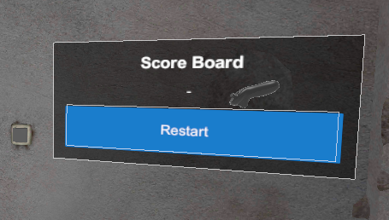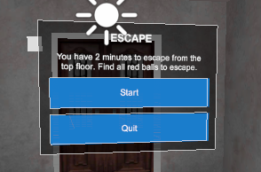

I then Also have the game over UI that follows the players view and when this UI pops up, our light is set to not active and we have to press the restart button.

If you do manage to grab all the balls to the target amount needed, You are transported to a new scene with a UI that says you have succeeded and you can either quit or restart the game.

# Scene Management

The game has two scenes in which if you reach the win condition, the next scene is the Win scene.

# Character/ Avatar Movement

For the character movement I’m using a character controller and the character controller driver components which is provided by to locomotion system. In the locomotion system, I added the continuous turn provider component and added 100 to turn speed and using the right-hand turn action for this condition. I also attached the continuous move provider to enable movement.

# 

# Physics, Lighting and Effects

For lighting, I used one area light that is a child to the XR rig so when we move around, the light is shining onto the environment we go to. This has helped with optimisation of lighting in the scene which created a more simplistic feel to the game.



References

Assets:

[Free Open Building | 3D Environments | Unity Asset Store](https://assetstore.unity.com/packages/3d/environments/free-open-building-112907)